P.SIRISHA

192110113

CSE

1.Average using array

import java.util.Scanner;

public class Main {

public static void main(String[] args) {

int marks[] = new int[3];

Scanner s = new Scanner(System.in);

for (int i = 0; i < marks.length; i++)

{

System.out.print("Enter marks for student " );

marks[i] = s.nextInt();

}

int sum = 0;

for (int i = 0; i < marks.length; i++) {

sum += marks[i];

}

double average = (double) sum / marks.length;

System.out.println("Average marks of 15 students: " + average);

s.close();

}

}

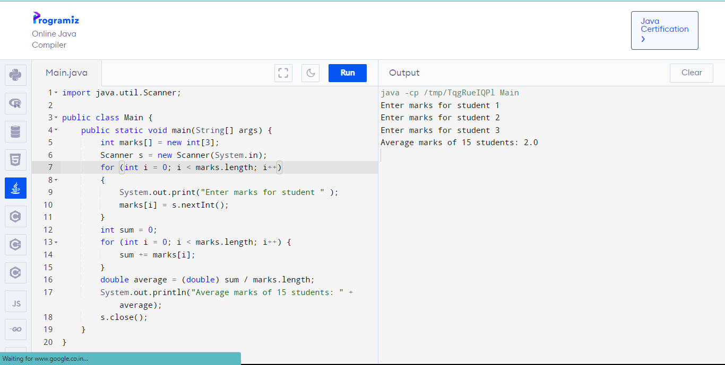

2.Area of rectangle

import java.util.\*;

class Rectangle

{

int l,b,t;

void area()

{

Scanner s =new Scanner(System.in);

System.out.println("enter the length");

l=s.nextInt();

System.out.println("enter the breadth");

b=s.nextInt();

int t=l\*b;

System.out.println("area is"+t);

}

}

class rec

{

public static void main(String args[])

{

Rectangle obj=new Rectangle();

obj.area();

}

}

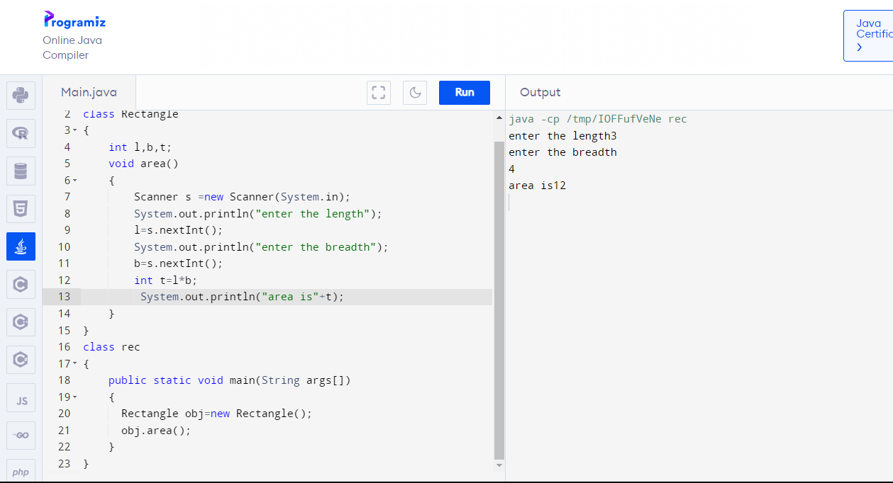

3.Area of circle

import java.util.\*;

class Circle

{

int r;

void area()

{

Scanner s =new Scanner(System.in);

System.out.println("enter the radius");

r=s.nextInt();

double t=(22\*r\*r)/7;

System.out.println("area is"+t);

}

}

class cir

{

public static void main(String args[])

{

Circle obj=new Circle();

obj.area();

}

}

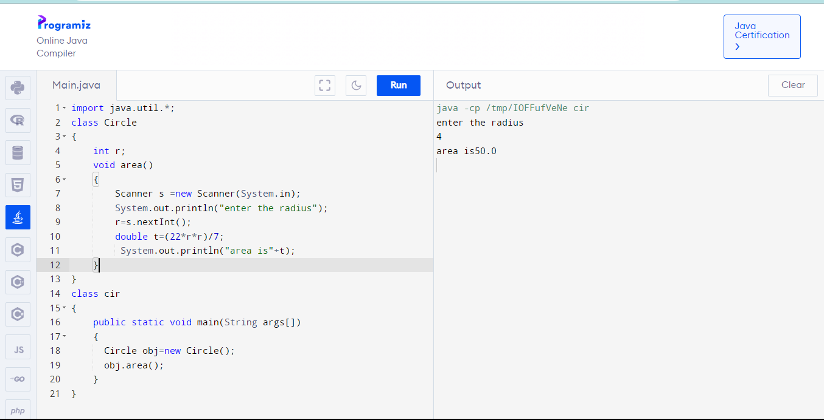

4.Area of triangle

import java.util.\*;

class Triangle

{

int b,h;

void area()

{

Scanner s =new Scanner(System.in);

System.out.println("enter the base");

b=s.nextInt();

System.out.println("enter the height");

h=s.nextInt();

int t=b\*h/2;

System.out.println("area is"+t);

}

}

class tri

{

public static void main(String args[])

{

Triangle obj=new Triangle();

obj.area();

}

}

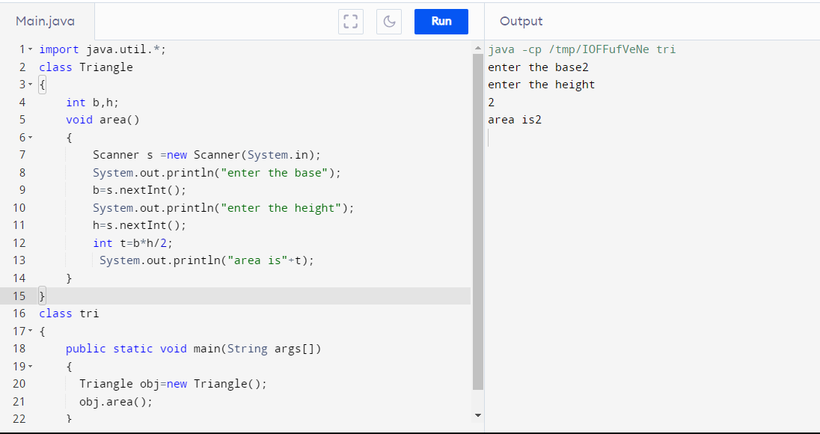

5.Simple interest

import java.util.\*;

class Interest

{

int p,t,r;

void cal()

{

Scanner s =new Scanner(System.in);

System.out.println("enter p");

p=s.nextInt();

System.out.println("enter r");

r=s.nextInt();

System.out.println("enter t");

t=s.nextInt();

int si=(p\*t\*r)/100;

System.out.println("simple intrest is"+si);

}

}

class simple

{

public static void main(String args[])

{

Interest obj=new Interest();

obj.cal();

}

}

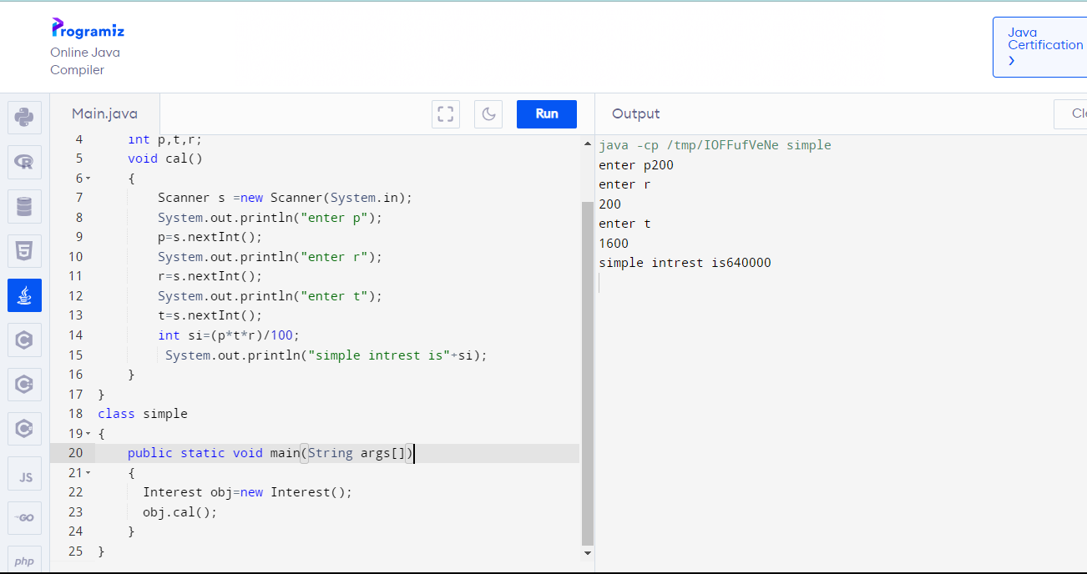

6.Argument constructor

class Box

{

double width,height,depth;

Box(double w,double h,double d)

{

width=w;

height=h;

depth=d;

}

double volume()

{

return width\*height\*depth;

}

public static void main(String args[])

{

Box b3=new Box(10.5,20.5,30.5);

double res=b3.volume();

System.out.println(res);

}

}

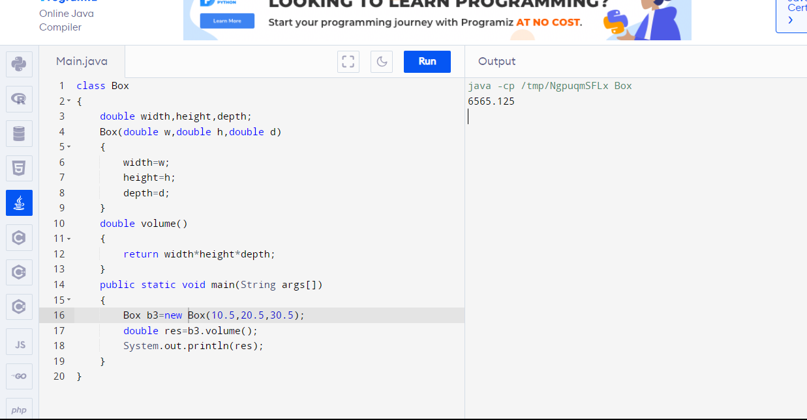

7.Sum of n terms in oops

import java.util.\*;

class Sum

{

int n,i,sum=0;

void add()

{

Scanner s=new Scanner(System.in);

System.out.println("enter number of terms");

n=s.nextInt();

for(i=1;i<=n;i++)

sum=sum+i;

System.out.println("sum is"+sum);

}

}

class addition

{

public static void main(String args[])

{

Sum obj=new Sum();

obj.add();

}

}

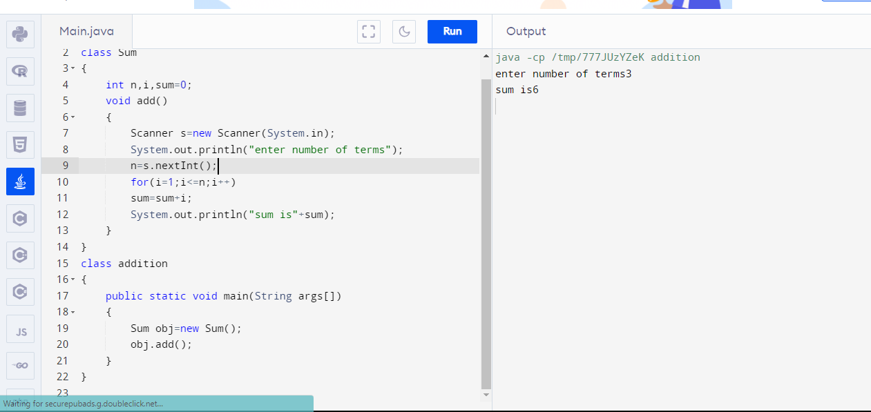

8.Matrix multiplication

public class MatrixMultiplication {

public static void main(String[] args) {

int[][] mat1 = {

{1, 2},

{5, 3}

};

int[][] mat2 = {

{2, 3},

{4, 1}

};

int[][] result = multiplyMatrices(mat1, mat2);

System.out.println("Mat Sum = ");

for (int i = 0; i < result.length; i++) {

for (int j = 0; j < result[0].length; j++) {

System.out.print(result[i][j] + " ");

}

System.out.println();

}

}

public static int[][] multiplyMatrices(int[][] mat1, int[][] mat2) {

int rows1 = mat1.length;

int cols1 = mat1[0].length;

int rows2 = mat2.length;

int cols2 = mat2[0].length;

if (cols1 != rows2) {

throw new IllegalArgumentException("Matrix dimensions are not compatible for multiplication");

}

int[][] result = new int[rows1][cols2];

for (int i = 0; i < rows1; i++) {

for (int j = 0; j < cols2; j++) {

int sum = 0;

for (int k = 0; k < cols1; k++) {

sum += mat1[i][k] \* mat2[k][j];

}

result[i][j] = sum;

}

}

return result;

}

}

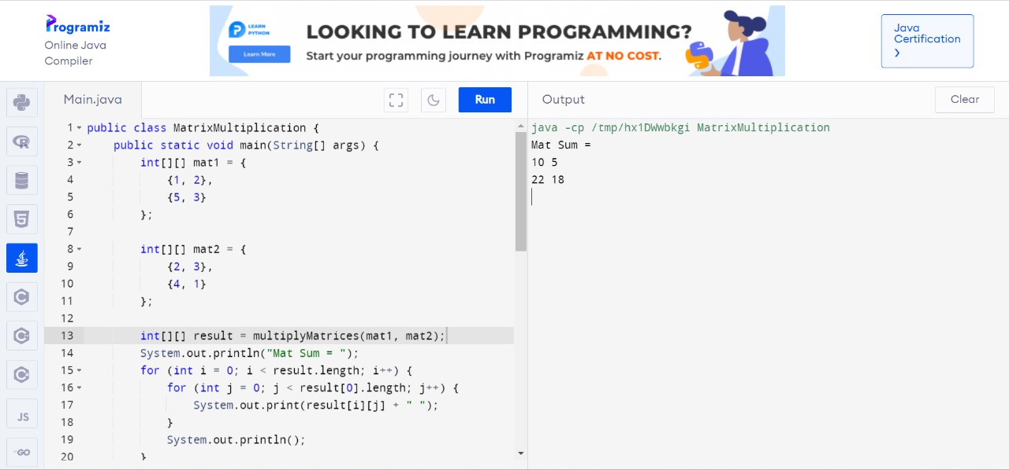

9.Matrix addition

import java.util.Scanner;

public class MatrixAddition {

public static void main(String[] args) {

Scanner scanner = new Scanner(System.in);

System.out.print("Enter the number of rows: ");

int rows = scanner.nextInt();

System.out.print("Enter the number of columns: ");

int columns = scanner.nextInt();

int[][] matrixA = new int[rows][columns];

int[][] matrixB = new int[rows][columns];

int[][] sumMatrix = new int[rows][columns];

System.out.println("Enter elements for Matrix A:");

for (int i = 0; i < rows; i++) {

for (int j = 0; j < columns; j++) {

System.out.print("Enter element at row " + (i + 1) + " and column " + (j + 1) + ": ");

matrixA[i][j] = scanner.nextInt();

}

}

System.out.println("Enter elements for Matrix B:");

for (int i = 0; i < rows; i++) {

for (int j = 0; j < columns; j++) {

System.out.print("Enter element at row " + (i + 1) + " and column " + (j + 1) + ": ");

matrixB[i][j] = scanner.nextInt();

}

}

for (int i = 0; i < rows; i++) {

for (int j = 0; j < columns; j++) {

sumMatrix[i][j] = matrixA[i][j] + matrixB[i][j];

}

}

System.out.println("Result of Matrix Addition:");

for (int i = 0; i < rows; i++) {

for (int j = 0; j < columns; j++) {

System.out.print(sumMatrix[i][j] + " ");

}

System.out.println(); // Move to the next row

}

scanner.close();

}

}

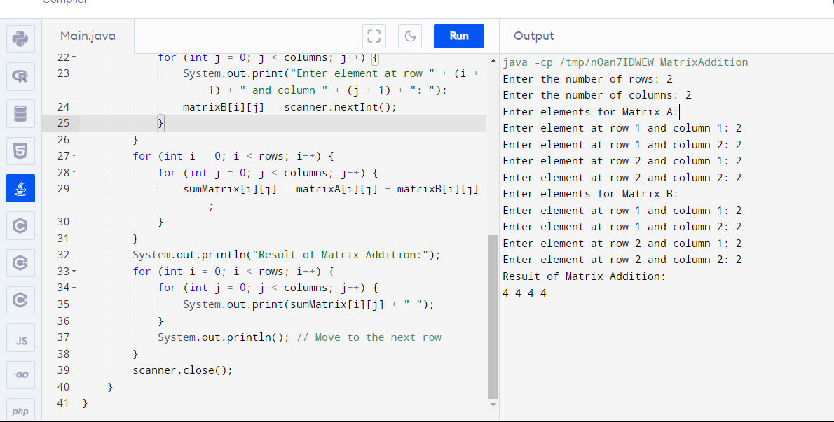

10.Constructor

import java.util.\*;

class AreaCircle

{

double area;

AreaCircle(double r)

{

area= 3.14\*r\*r;

}

}

class CrArea

{

public static void main(String args[])

{

Scanner sc= new Scanner(System.in);

System.out.println("Enter the radius of circle");

double radius= sc.nextDouble();

AreaCircle obj =new AreaCircle(radius);

System.out.println("Area of Circle is " + obj.area);

}

}

